**Calculating Family Expenses using Service Now**

**Team Id: NM2025TMID13751**

**Team Members:4**

**Team Leader: DINESH KUMAR D**

**Team Member: SATHYA K**

**Team Member: NITHISH S**

**Team Member : SANJAY S**

**Problem Statement:**

The project aims to develop a comprehensive expense calculation system using ServiceNow. This system will enable users to track and manage family expenses efficiently. It will include features such as expense categorization, budget setting, real-time tracking, and reporting capabilities. Utilizing ServiceNow's robust platform, the project will ensure seamless integration, user-friendly interface, and scalability to accommodate varying family sizes and financial complexities. The end goal is to empower users with the tools they need to make informed financial decisions and promote financial well-being within the family unit.

**Objective:**

Creating Family Expenses table

**Skills:**

Setting up ServiceNow Instance,Creation of New Update Set,Creation of Table,Creation of Relationship,Configuring Related List,Creation of Business Rules,Configure the Relationship

**TASK INITIATION**

**Milestone 1 : Users**

**Activity 1: Creation of New Update Set**

* Go to All >> In the filter search for Local Update set > click on New.

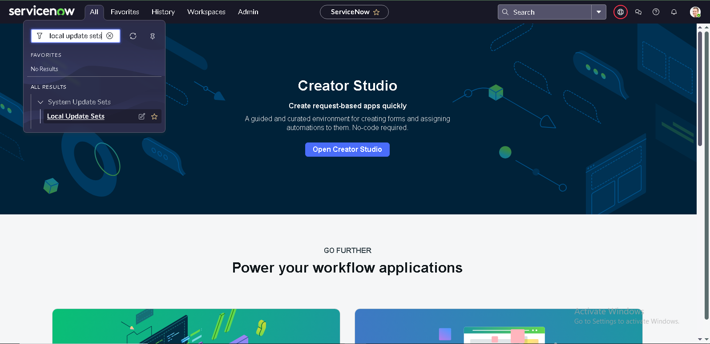

* Enter the Details as:
* Name : Family Expenses
* Then click on Submit and Make current.

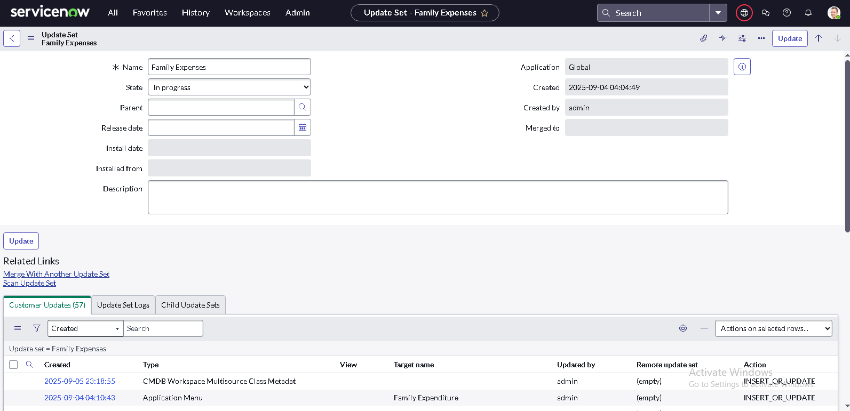

**Milestone 2 : Creation of Table**

**Activity 1: Creation of Family Expenses Table**

* Go to All > In the filter search for Tables > click on New.
* Enter the Details:
* Label : Family Expenses
* Name : Auto-Populated
* New menu name : Family Expenditure

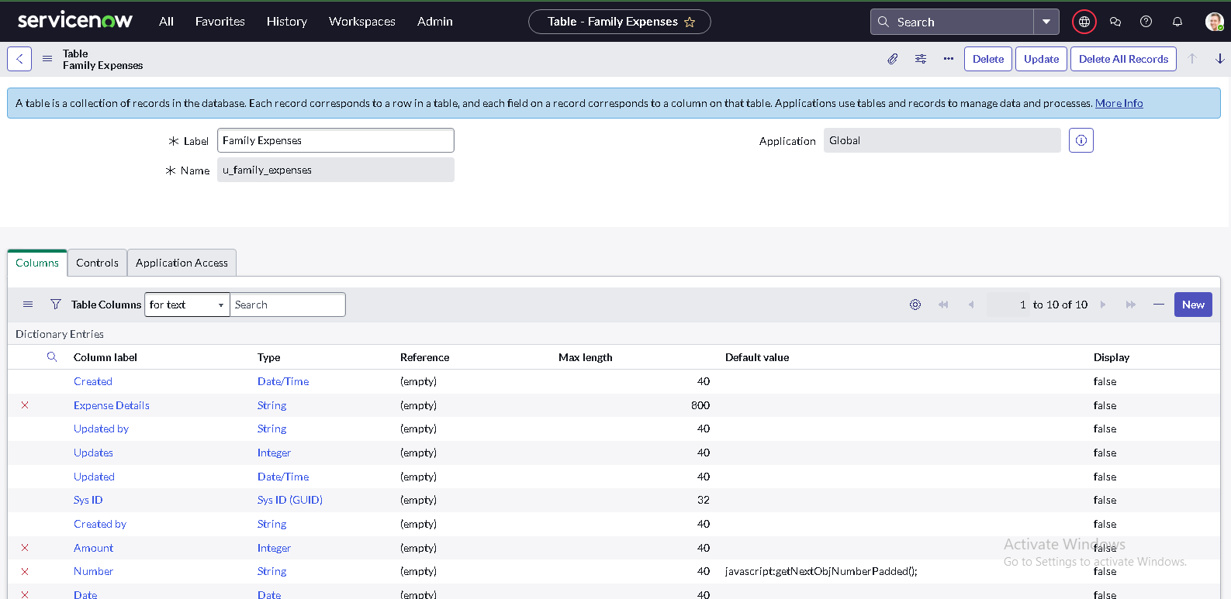

Go to the Header and right click there>> click on Save

**Activity 2: Creation of Columns(Fields)**

* Near Columns Double click near insert a new row.
* Give the details as:
* Column label : Number
* Type : String
* Double click on insert a new row again
* Give the details as:
* Column label : Date
* Type : Date
* Double click on insert a new row again
* Give the details as:
* Column label : Amount
* Type : Integer
* Double click on insert a new row again
* Give the details as:
* Column label : Expense Details
* Type : String
* Max length : 800



* Go to the Header and right click there>> click on Save.

**Activity 3: Making Number Field an Auto-Number**

* Double click on the Number Field/Column.
* Go down and double click on Advanced view
* In Default Value:
* Use dynamic default : check the box
* Dynamic default value : Get Next Padded Number
* Click on Update.

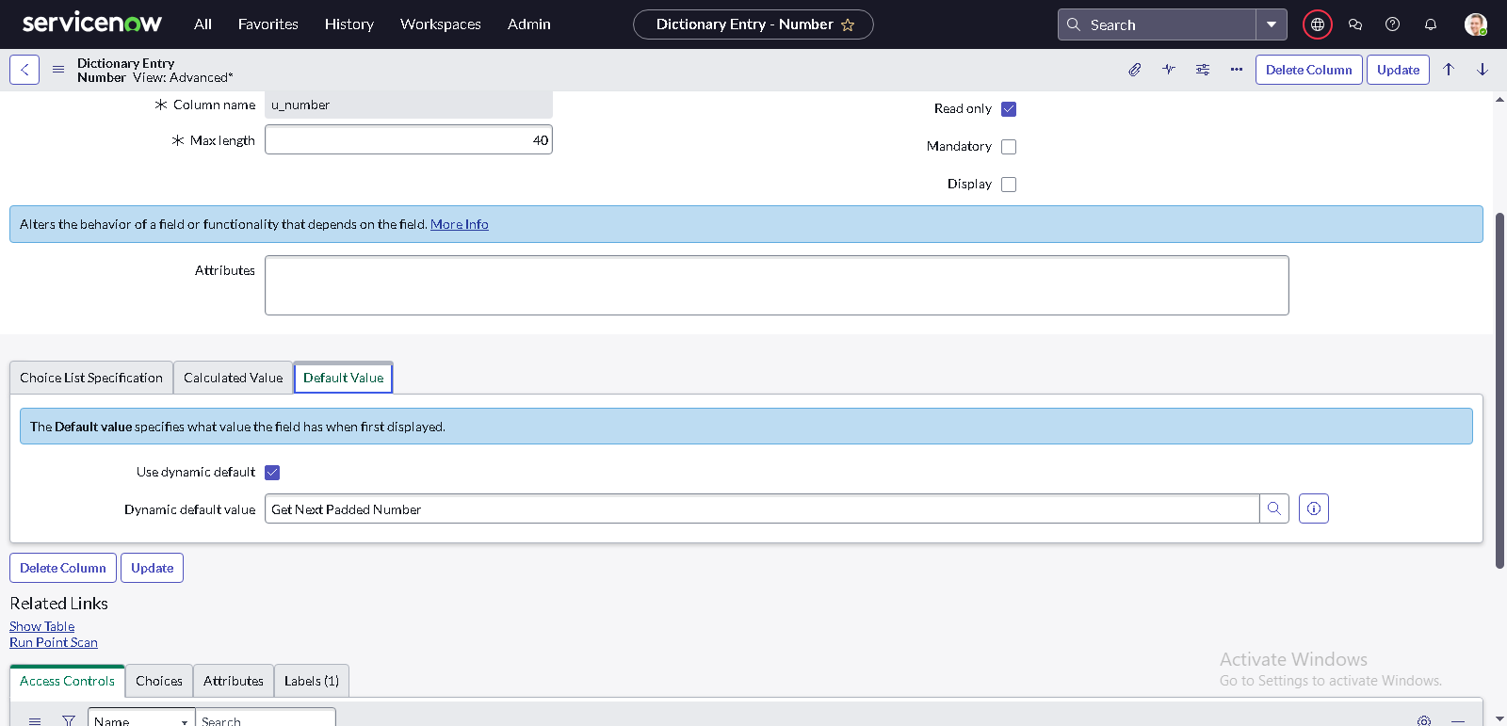

* Go to All >> In the filter search for Number Maintenance >> select Number Maintenance
* Click on New.
* Enter the below Details:
* Table : Family Expenses
* Prefix : MFE

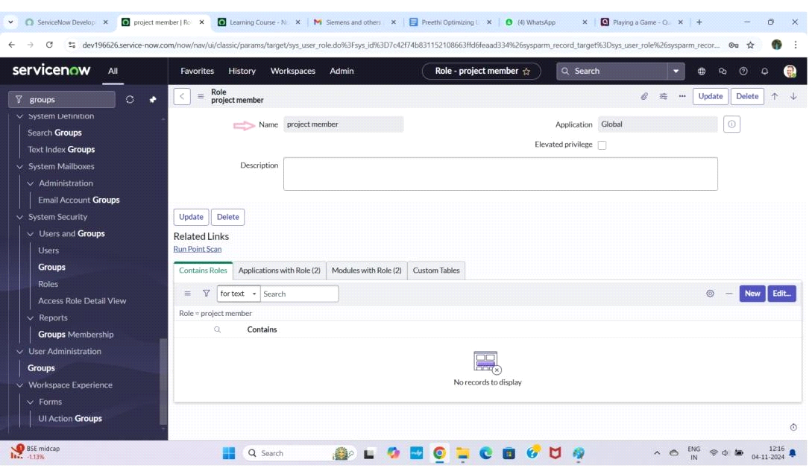

* Click on Submit.

**Activity 4: Configure the Form**

* Go to All >> In the filter search for Family Expenses >> Open Family Expenses
* Click on New
* Go to the Header and right click there>> click on Configure >> Select Form Design
* Customize or Drag Drop the form as per your requirement.

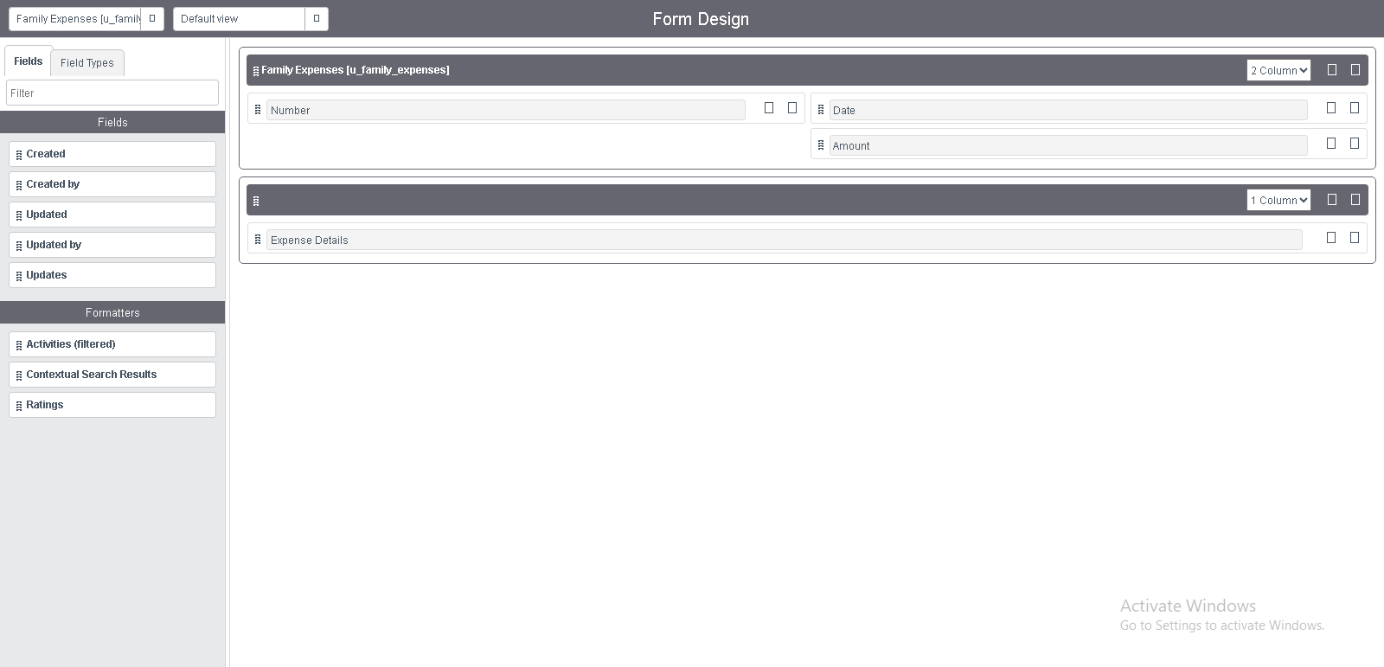

* Make Number Read-Only Field by clicking on the gear icon and checking Read-Only
* Make Date, Amount Mandatory Field by clicking on the gear icon and checking Mandatory
* Click on Save.

**Milestone 3 : Creation of Table(Daily Expenses)**

**Activity 1: Creation of Daily Expenses Table**

* Go to All > In the filter search for Tables > click on New.
* Enter the Details:
* Label : Daily Expenses
* Name : Auto-Populated
* Add Module to menu : Family Expenditure

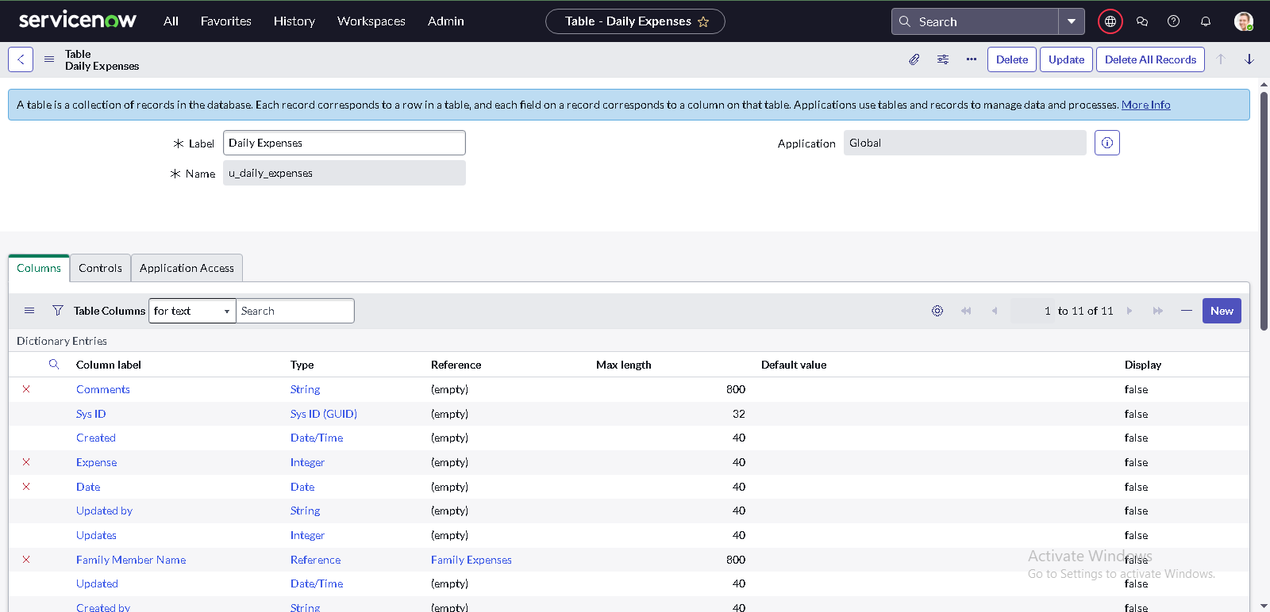

* Go to the Header and right click there>> click on Save.

**Activity 2: Creation of Columns(Fields)**

* Near Columns Double click near insert a new row.
* Give the details as:
* Column label : Number
* Type : String
* Double click on insert a new row again
* Give the details as:
* Column label : Date
* Type : Date
* Double click on insert a new row again
* Give the details as:
* Column label : Expense
* Type : Integer
* Double click on insert a new row again
* Give the details as:
* Column label : Family Member Name
* Type : Reference
* Max length : 800
* Double click on insert a new row again
* Give the details as:
* Column label : Comments
* Type : String
* Max length : 800



* Go to the Header and right click there>> click on Save.

**Activity 3: Making Number Field an Auto-Number**

* Making Number Field an Auto-Number
* Double click on the Number Field/Column.
* Go down and double click on Advanced view
* In Default Value:
* Use dynamic default : check the box
* Dynamic default value : Get Next Padded Number
* Click on Update.

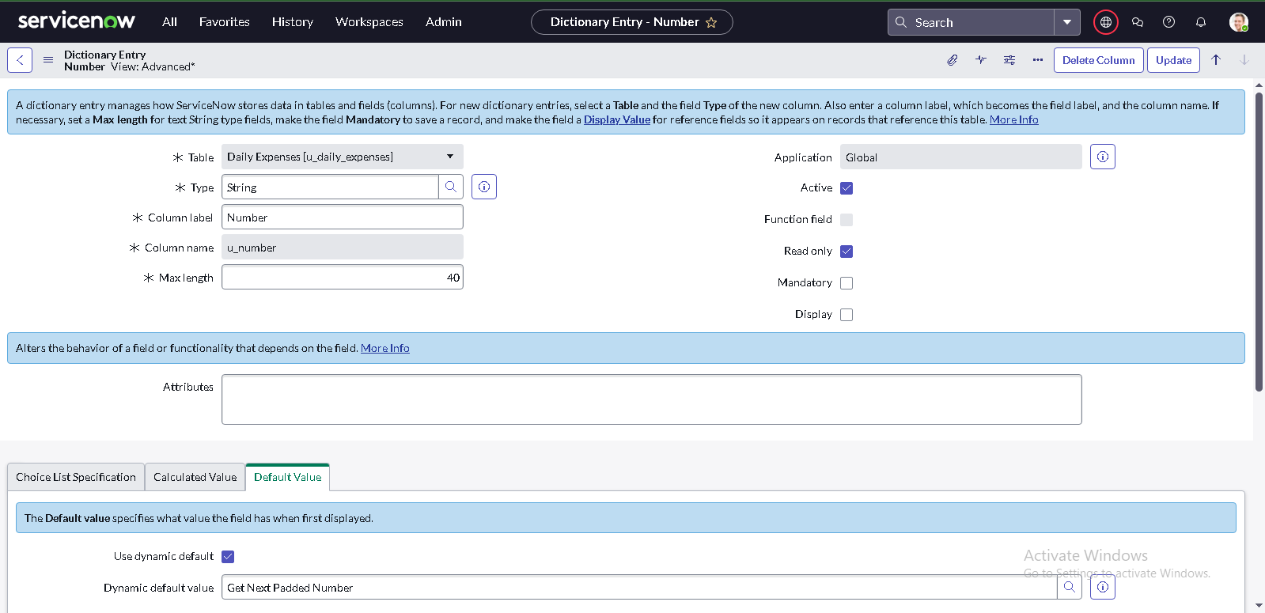

* Go to All >> In the filter search for Number Maintenance >> select Number Maintenance
* Click on New.
* Enter the below Details:
* Table : Family Expenses
* Prefix : MFE

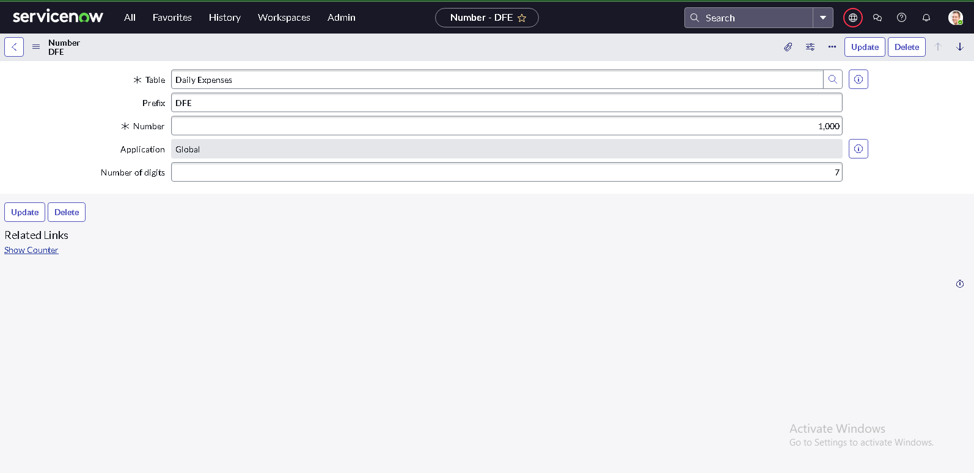

* Click on Submit.

**Activity 4: Configure the Form**

* Go to All >> In the filter search for Daily Expenses >> Open Daily Expenses
* Click on New
* Go to the Header and right click there>> click on Configure >> Select Form Design
* Customize or Drag Drop the form as per your requirement.

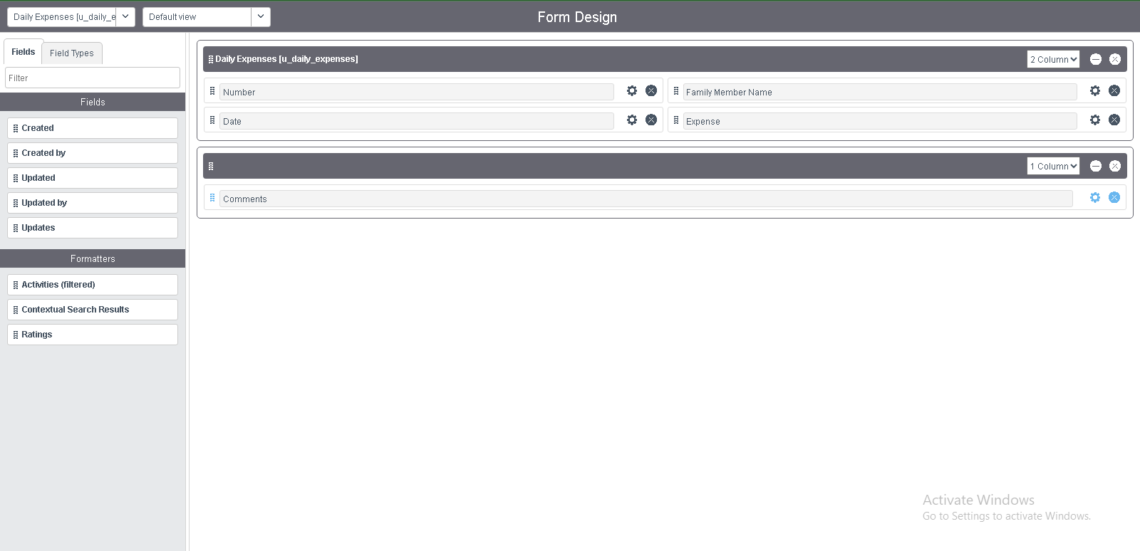

* Make Number Read-Only Field by clicking on the gear icon and checking Read-Only
* Make Date, Family Member Name Mandatory Field by clicking on the gear icon and checking Mandatory
* Click on Save.

**Milestone 4 : Creation of Relationship**

**Activity 1: Creation of Relationship between Family Expenses and**

**Daily Expenses tables**

* Go to All >> In the filter search for Relationships >> Open Relationships
* Click on New.
* Enter the details:
* Name : Daily Expenses
* Applies to table : Select Family Expenses
* Daily Expenses : Select Daily Expenses
* Click Save.

**Milestone 5 : Configuring Related List on Family Expenses**

**Activity 1: Configuring Related List on Family Expenses**

* Go to All >> In the filter search for Family Expenses >> Open Family Expenses
* Click on New
* Go to the Header and right click there>> click on Configure >> Select Related Lists
* Add Daily Expenses to the Selected Area.
* Click on Save

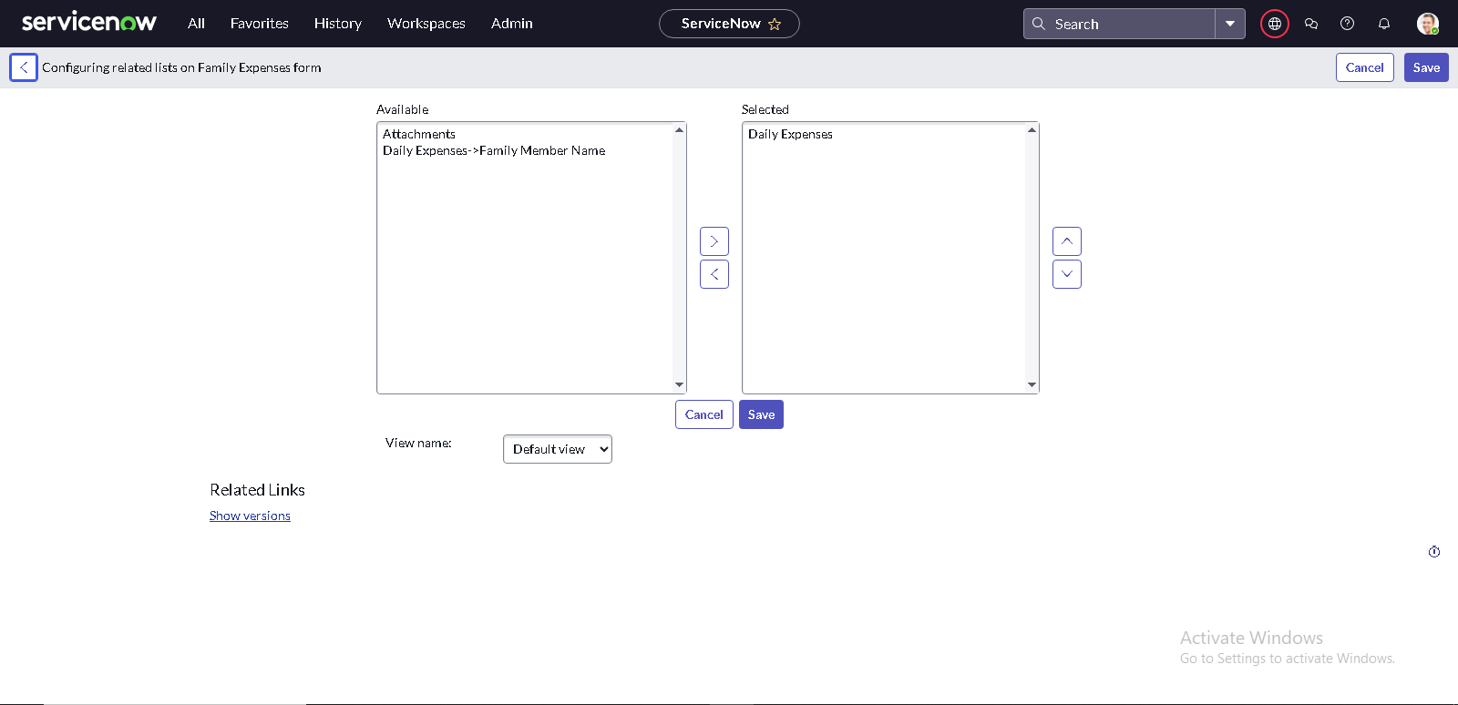

**Milestone 6 : Creation of Business Rules**

**Activity 1: Creation of Business Rules**

* Go to All >> In the filter search for Business Rules.
* Under System Definition Select Business Rules then click on New.
* Enter the Details:
* Name : Family Expenses BR
* Table : Select Daily Expenses
* Check Advanced

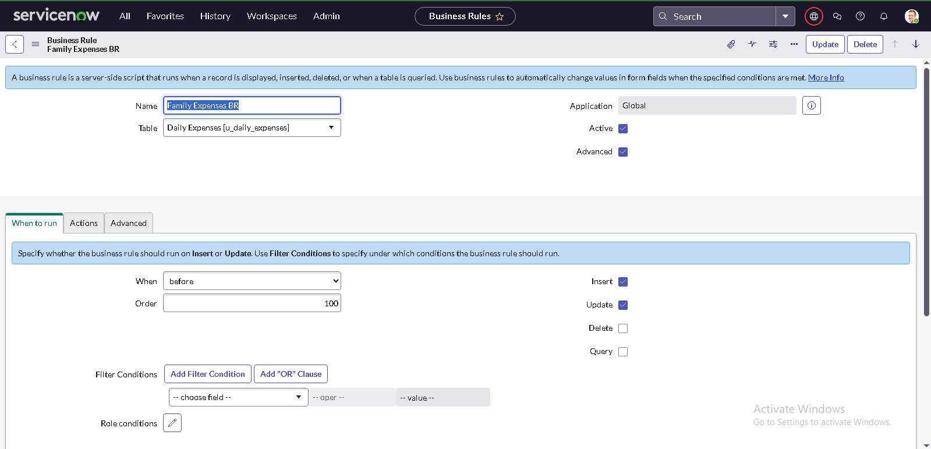

* In when to run Check Insert and Update

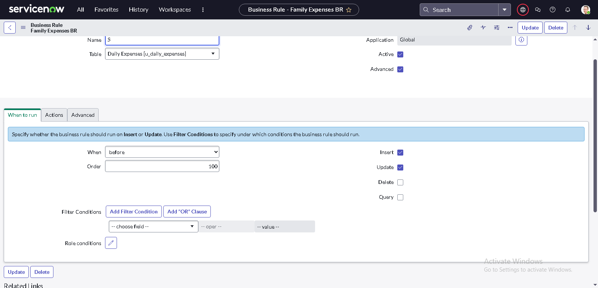

* In Advance(we write the code): Write the below code >>

(function executeRule(current, previous /*null when async*/) {

var FamilyExpenses = new GlideRecord('u_family_expenses');

FamilyExpenses.addQuery('u_date',current.u_date);

FamilyExpenses.query();

if(FamilyExpenses.next())

{

FamilyExpenses.u_amount += current.u_expense;

FamilyExpenses.u_expense_details += ">"+current.u_comments+":"+"Rs."+current.u_expense+"/-";

FamilyExpenses.update();

}

else

{

var NewFamilyExpenses = new GlideRecord('u_family_expenses');

NewFamilyExpenses.u_date = current.u_date;

NewFamilyExpenses.u_amount = current.u_expense;

NewFamilyExpenses.u_expense_details += ">"+current.u_comments+":"+"Rs."+current.u_expense+"/-";

NewFamilyExpenses.insert();

}

})(current, previous);

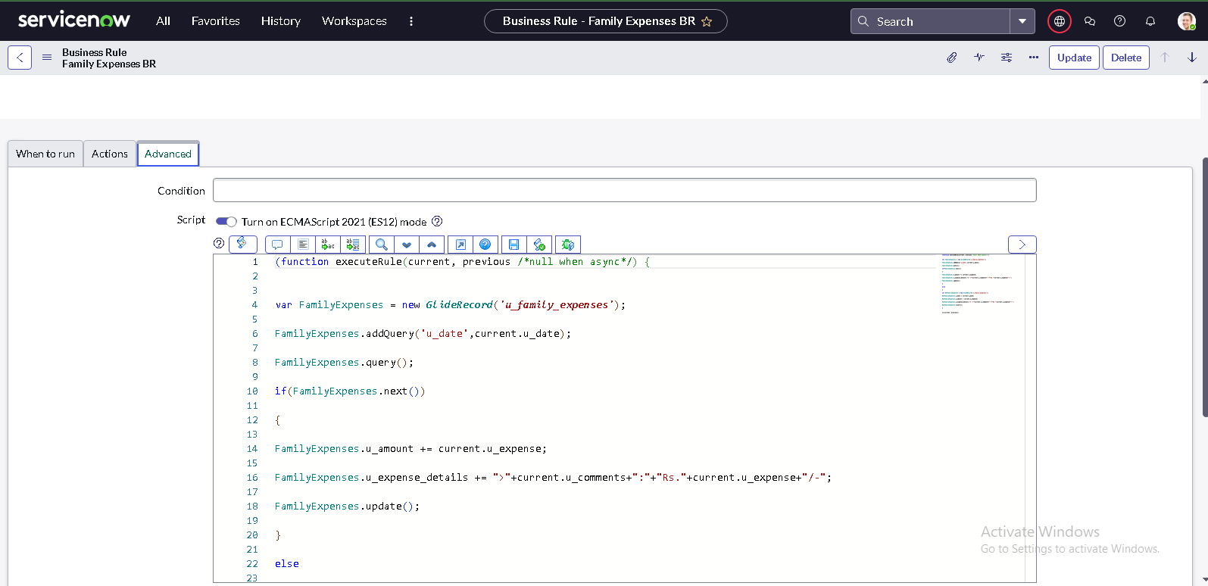

Go to the Header and right click there>> click on Save.

**Milestone 7 : Configure the Relationship**

**Activity 1: Configure the Relationship**

* Go to All >> In the filter search for Relationships >> Open Relationships.
* In that, open Daily Expenses Relationship.
* For Applies to table : Select Family Expenses.
* In Query with : write the below Query.

(function refineQuery(current, parent) {

// Add your code here, such as current.addQuery(field, value);

current.addQuery('u_date',parent.u_date);

current.query();

})(current, parent);

Click on Update.

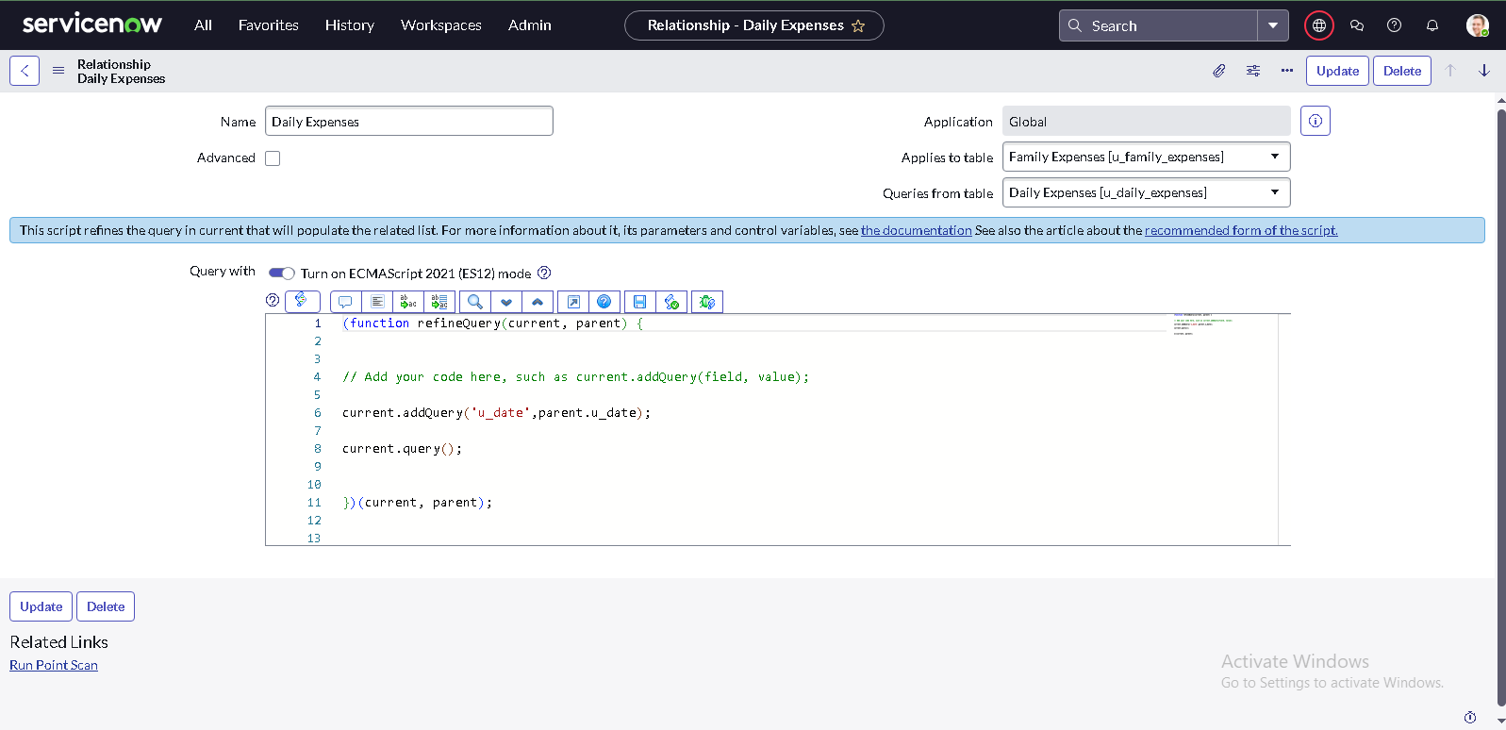

**Conclusion :**

The Family Expense Calculation System built on ServiceNow offers a smart and streamlined way to manage household finances. By enabling expense categorization, budget tracking, and insightful reporting, it simplifies financial management and empowers families to control their spending effectively. This system not only enhances financial transparency but also fosters disciplined money management, ultimately supporting sustainable financial growth and stability.